<ADF test>

|  |  |  |
| --- | --- | --- |
|  | **rawdata : ADFtest** | **Diff : ADFtest** |
| **BTC_price** | 4.6717 | -16.047 ** |
| **Gold_price** | -2.3001 | -14.899 |
| **Bond_yield** | -1.9956 | -13.639 |
| **KOSPI** | -1.4036 | -13.147 |
| **USD_exchange_rate** | -2.5564 | -15.133 |
| **BTI_circulation** | -2.1097 | -4.3642 |
| **VIX** | -5.2976** | -14.591 |
| **NASDAQ** | -1.0039 | -13.431 |
| **VKOSPI** | -5.201** | -13.748 |
| **S&P500** | -2.7078 | -12.994 |
| **Nvidia** | -1.0565 | -15.146 |
| **AMD** | -1.3049 | -13.52 |
| **MA** | -2.0721 | -13.24 |
| **PAPL** | -1.2105 | -13.551 |
| **SQ** | -0.19523 | -14.473 |
| **vidente** | -2.992 | -14.536 |

<Correlation(rawdata,diff)>

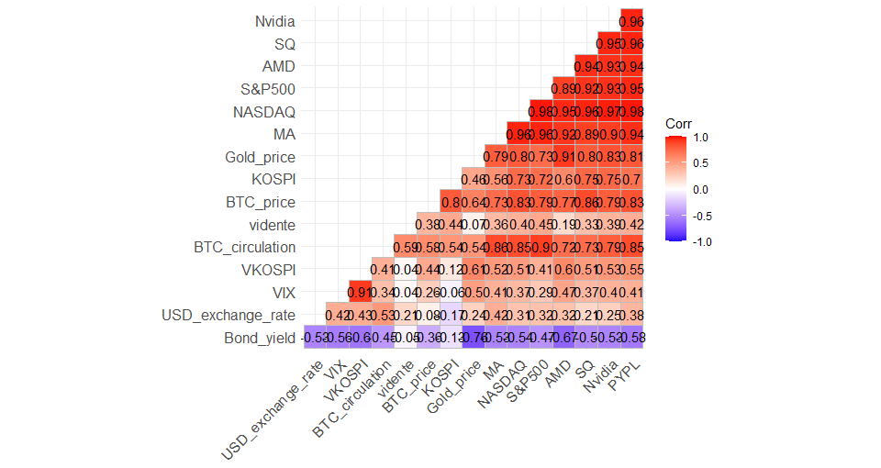

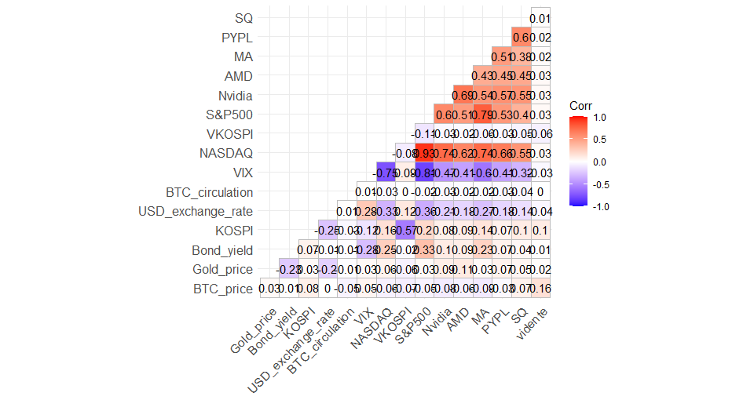

<Granger Causality Test>

1. H0: X does not Granger cause BTC_price
2. H0: BTC_price does not Granger cause X

|  |  |
| --- | --- |
|  | **1. Lag=8** |
| **Gold_price** | 0.06975 |
| **Bond_yield** | 0.1775 |
| **KOSPI** | 0.0000004964 *** |
| **USD_exchange_rate** | 0.04584 * |
| **BTI_circulation** | 0.2849 |
| **VIX** | 0.00000000003129 *** |
| **NASDAQ** | 0.00000000000002298 *** |
| **VKOSPI** | 0.06724 |
| **S&P500** | 0.000000002384 *** |
| **Nvidia** | 0.000000006628 *** |
| **AMD** | 0.000172 *** |
| **MA** | 0.000000008458 *** |
| **PYPL** | < 2.2e-16 *** |
| **SQ** | < 2.2e-16 *** |
| **vidente** | 0.0002633 *** |

**VARselect-> selected lag=8**

**Delected variables which are not satisfied Granger Causality**

<Impulse Response Analysis >

